UNCLASSIFIED
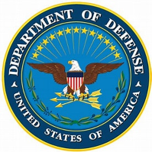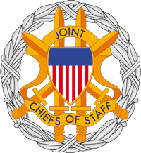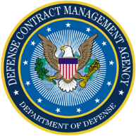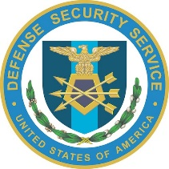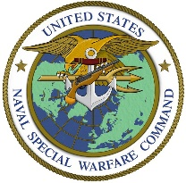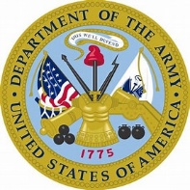

MILITARY WHISTLEBLOWER PROTECTION ACT COMMUNICATION

http://20.kremlin.ru/2012/events/464/1573

464/1573

Forms | FDA - U.S. Food and Drug Administration
https://www.fda.gov/about-fda/reports-manuals-forms/forms
Depending on the browser you are using, you may need to download the form to enable field fillable functionality. Use the following instructions to download the form if you encounter an issue:
Forms | FDA https://www.fda.gov/about-fda/reports-manuals-forms/forms
Number of Gas Producing Oil Wells (eia.gov) Homepage - U.S. Energy Information Administration (EIA)
^{[PDF]}

Texas
https://www.tjjd.texas.gov/index.php/doc-library/...
Created Date: 4/11/2017 10:47:54 AM
Document Library (texas.gov) https://www.tjjd.texas.gov/index.php/doc-library
Office of the Texas Governor | Greg Abbott
1947-04_0.pdf (uscourts.gov) https://www.uscourts.gov/

UNCLASSIFIED

INDYCAR SERIES Photo Gallery https://www.indycar.com/photos/gallery?g=1573
Indianapolis Motor Speedway https://www.indianapolismotorspeedway.com
NetJets | World's Leading Private Jet Company | Fractional Aircraft Companies
NetJets Inc. is a Berkshire Hathaway company. https://netjets.com/en-us/
BERKSHIRE HATHAWAY INC. Private Charter Flights | Charter Flight Experience | EJM (executivejetmanagement.com)
https://www.netjet.com/en-gb/private-jet-access?go=largest-fleet BERKSHIRE HATHAWAY INC. https://herkshirehathaway.com
Our Private Jet Fleet | Size, Global Access & Locations | NetJets
+44 207 361 96205 Young Street London United Kingdom W8 5EH
NatWest Group
https://www.natwestgroup.com/who-we-are-brands.html
Holt's | Our brands | NatWest Group Our brands | NatWest Group
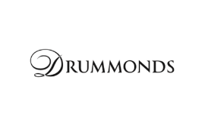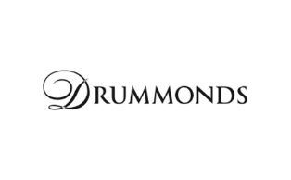
Holt's Military Banking | UK Military Banking (holtsmilitarybanking.co.uk)
https://www.holtsmilitarybanking.co.uk/home.html?

UNCLASSIFIED
BERKSHIRE HATHAWAY INC.
Home | QS Partners
PAUL KIRBY

Commission Man: Paul Kirby, Commtech - MEP Middle East
https://www.mepmiddleeast.com/news/article-21873...
Apr 12, 2013 · Commission Man: Paul Kirby, Commtech - MEP Middle East MEP Middle East MEP Middle East is a monthly magazine that delivers news, data, analysis and strategic insights for the region's mechanical, electrical and plumbing (MEP) contractors, as well as those specifying the MEP components needed for new developments. News

sensaire

Sensaire Services - Construction Week Online
https://www.constructionweekonline.com/lists/...
Jun 01, 2016 · Dubai-based Sensaire Services’ last recorded figures show that it made revenue of $62m in 2014. The audit for the 2015 financial year is still being finalised. In the meantime, the company predicts that it will make around …

Anel - Construction Week Online

July 18–24. Ezra 1; 3–7; Nehemiah 2; 4–6; 8: “I Am Doing a Great …
https://www.churchofjesuschrist.org/study/manual...
3–7. ; Nehemiah 2. ; 4–6. ; 8. “I Am Doing a Great Work”. President Ezra Taft Benson taught, “The word of God … has the power to fortify the Saints and arm them with the Spirit so they can resist evil, hold fast to the good, and find joy in this life” ( Teachings of Presidents of the Church: Ezra Taft Benson [2014], 118 ).

1 6 6 1 7 3

Rule 1.6: Confidentiality of Information - American Bar Association

UNCLASSIFIED

https://www.americanbar.org/.../rule_1_6_confidentiality_of_information
(6) to comply with other law or a court order; or (7) to detect and resolve conflicts of interest arising from the lawyer’s change of employment or from changes in the composition or ownership of a firm, but only if the revealed information would not compromise the attorney-client privilege or otherwise prejudice the client.

Rule 1.6: Confidentiality of Information (americanbar.org)

I CERTIFY UNDER PENALTY OF PERJURY UNDER THE LAWS OF THE UNITED STATES OF AMERICA, I AM AN EMPLOYEE OF THE UNITED STATES GOVERNMENT (TITLE 18 U.S.C. SECTION 1114), (TITLE 18 U.S.C. SECTION 1961(10)), DEPARTMENT OF DEFENSE. I AM A US ARMY SPECIAL OPERATIONS DELTA FORCE-NATIONAL NUCLEAR SECURITY OFFICER (NATIONAL NUCLEAR SECURITY ADMINISTRATION). I AM A MEMBER IN GOOD STANDING OF THE NATIONAL TELECOMMUNICATIONS SECURITY WORKING GROUP, COMMITTEE ON NATIONAL SECURITY SYSTEMS, NATIONAL SECURITY AGENCY. I AM ASSIGNED TO THE OFFICE OF THE SECRETARY OF DEFENSE, DEFENSE INTELLIGENCE AGENCY, JOINT CHIEFS OF STAFF. I HAVE PERSONAL KNOWLEDGE OF THE FACTS STATED IN THIS MILITARY WHISTLEBLOWER PROTECTION ACT COMMUNICATION WEBSITE-COMPLAINT PROGRAM. THAT THE FOREGOING DOCUMENT(S) ARE TRUE AND CORRECT, TO THE BEST OF MY KNOWLEDGE AND BELIEF, PURSUANT TO THE PROVISIONS OF TITLE 28 U.S.C. SECTION 1746. UPDATED AND EXECUTED ON 9/15/2022.
/s/WILLIAM MAVERICK WINSLOW AC 56
OFFICE OF THE SECRETARY OF DEFENSE
U.S. ARMY SPECIAL OPERATION-DELTA FORCE
DEFENSE CONTRACT MANAGEMENT AGENCY
NATIONAL NUCLEAR SECURITY ADMINISTRATION (CTOS), (DOE) - "Q"
DEFENSE COUNTERINTELLIGENCE AND SECURITY AGENCY/DEFENSE SECURITY SERVICE

